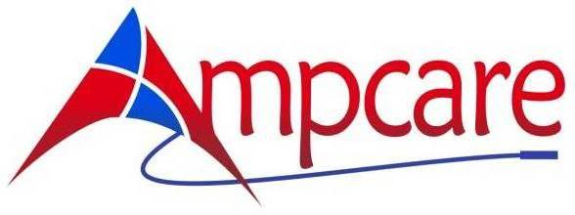

**Deciphering Dysphagia with Ampcare’s ESP™ (Effective Swallowing Protocol)**

**Monday, 3 October 2016**

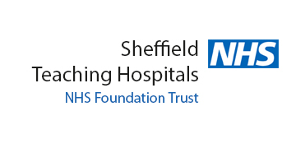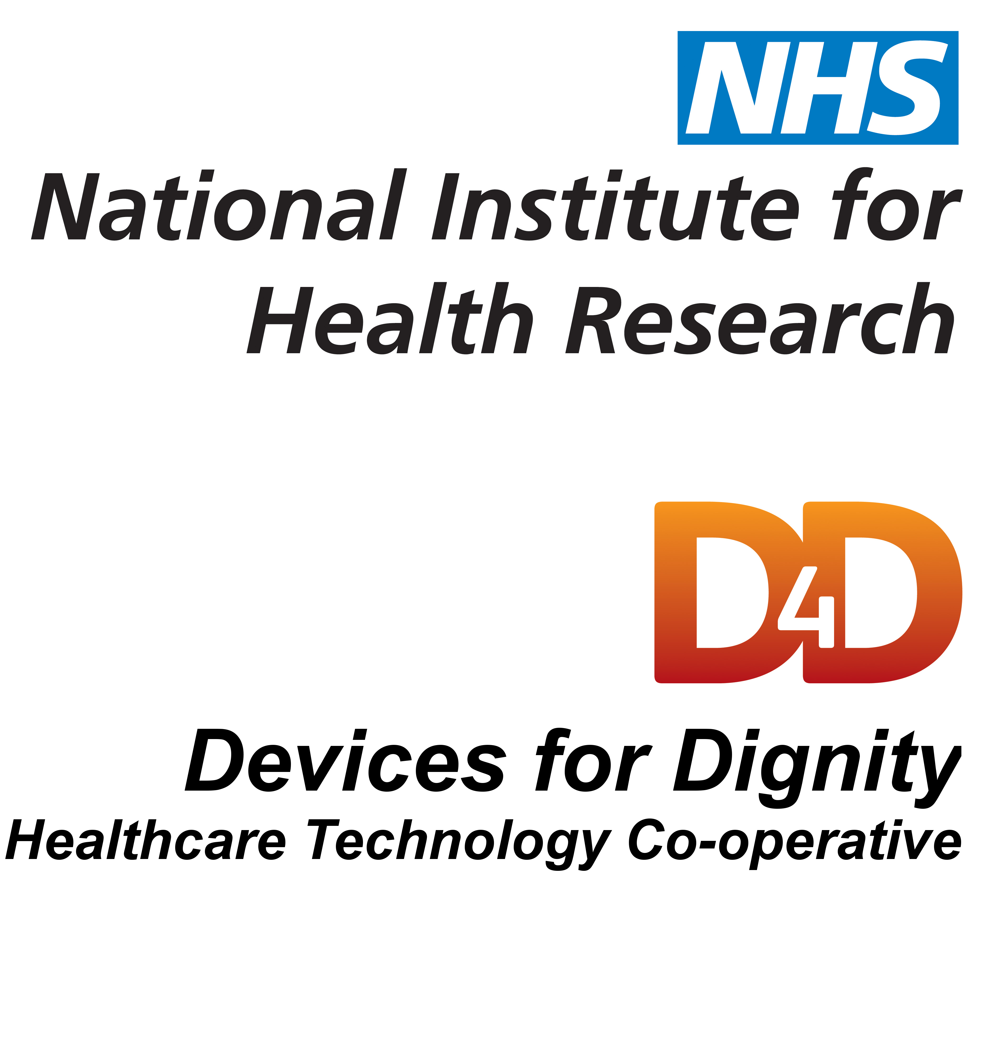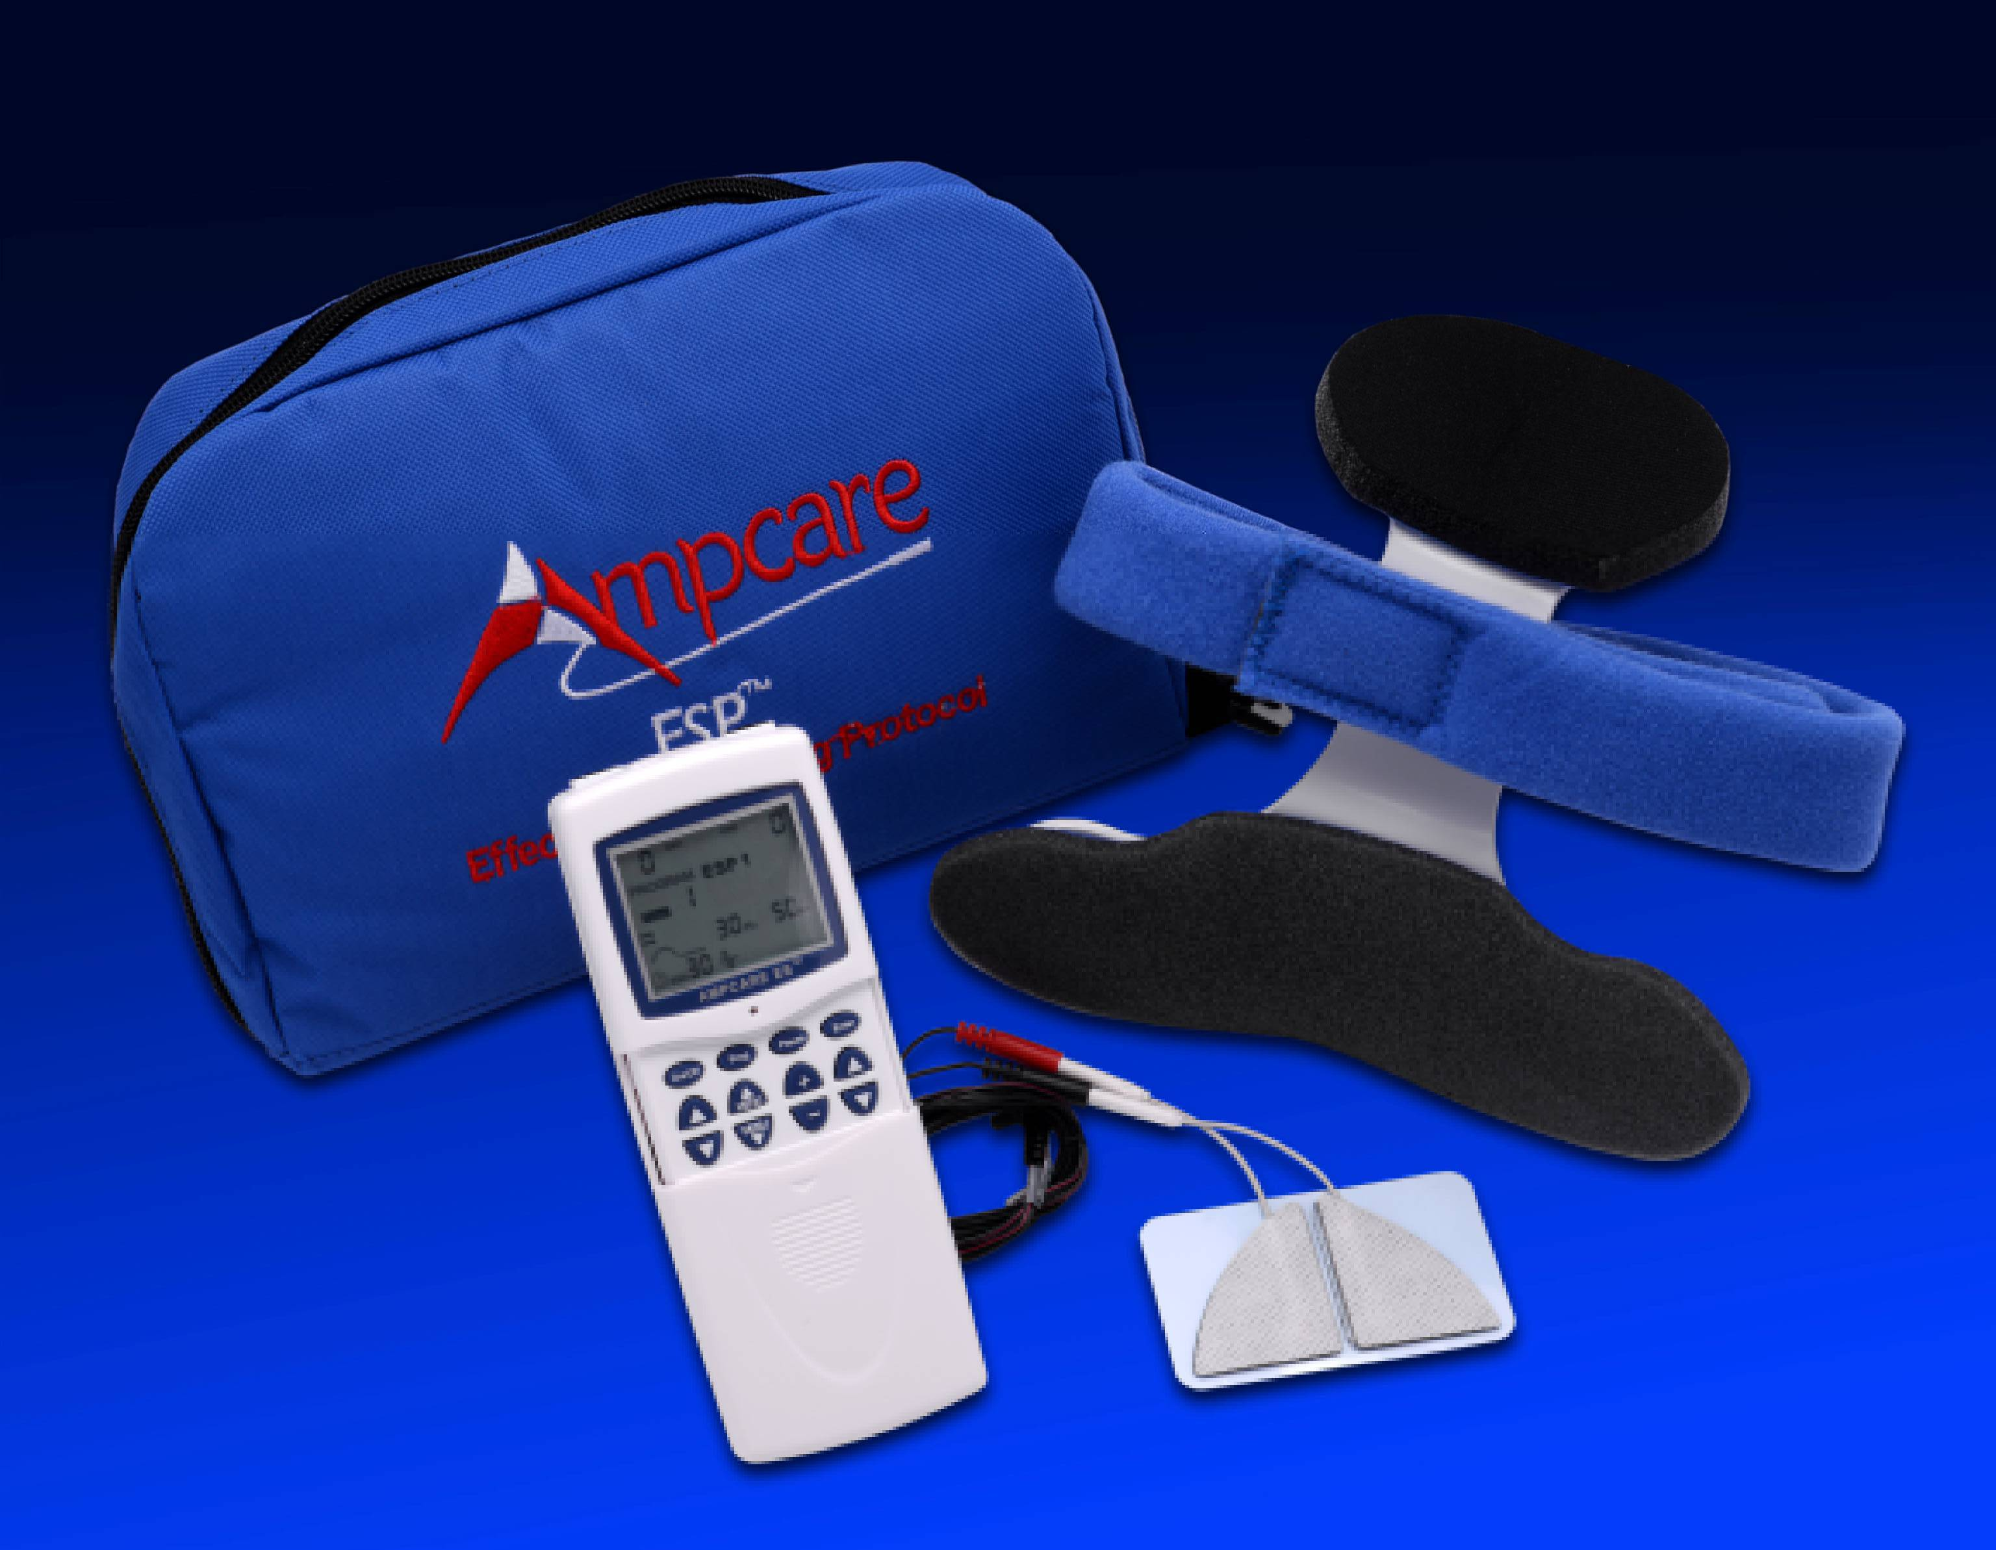

* **Become Certified in ESP, the Most Comprehensive FDA-Cleared Treatment for Dysphagia**
* **Learn the Latest Assessment Techniques**
* **Accelerate Recovery by Combining Neuromuscular Electrical Stimulation with Resistive Exercise**
* **Do More in 30 Minutes**
* **Earn 0.8 ASHA CEUs**

**Course location:**

**DoubleTree by Hilton**

**Sheffield Park,**

**Chesterfield Road South, Sheffield S8 8BW**

**United Kingdom  
Tel: 0114 2829988**

**New 30-minute Treatment for Dysphagia**

Ampcare’s patented and FDA-cleared system for dysphagia treatment takes traditional therapy approaches to the next level. Ampcare’s ESP (Effective Swallowing Protocol) unites the benefits of neuromuscular electrical stimulation (NMES) while incorporating proper postural strategies and resistive exercises.



**Patient at rest** **Patient receiving ESP**

This seminar will guide clinicians through the latest clinical approach to treat dysphagia. Ampcare’s ESP combines NMES with specifically designed electrodes to fit the submental and facial areas to work in conjunction with indirect (NPO) techniques and newly-developed therapeutic exercises. This systematic rehabilitation approach works to improve hy0-laryngeal excursion and enhance swallowing posture by providing the tools to accelerate swallow function.

This course will teach participants the specific rationale behind the parameters best suited for small muscle rehabilitation, review the anatomy of the muscle groups and cranial nerves associated with the swallow, and provide extensive “hands on” experience using the technique.

**Participants will receive:**

• 1 (one) package of FDA 510(k) cleared Ampcare E Series Electrodes

• Course manual, which will be reviewed with a PowerPoint presentation, and includes pictures, exercises and flow chart for demonstration purposes and enhanced learning

**Agenda:**

8:00-8:30 Registration

8:30-8:45 Developing the Concept for ESP

8:45-9:15 Evidence-Based Research Validating ESP

9:15-10:15 Anatomy and Physiology as it Relates to NMES

10:15-10:30 Break

10:30-10:45 Cranial Nerve Assessment for Dysphagia

10:45-11:15 Muscle Fibers and Recruitment Patterns

11:15-12:00 Fundamental Principles of NMES and Ampcare ESP Parameters

12:00-12:30 Lunch (provided)

12:30-1:00 Videofluoroscopy of ESP

1:00-2:15 Electrode Placements, Restorative Posture Device & Recommended Exercises

2:15-3:15 Hands on Lab, Programming the Ampcare ES unit and Electrode Applications

3:15-3:30 Break

3:30-4:15 ESP for Oral Motor Management - Facial Placement

4:15-4:45 Introducing Ampcare’s ESP to the UK

4:45-5:00 Post Test, Q & A

This accredited continuing medical education activity is copyrighted © 2013 by AMPCARE, LLC 14.Rev.A

**Accreditation**



**This course is offered for 0.8 CEU’s (Advanced level, Professional area)**

**Faculty**

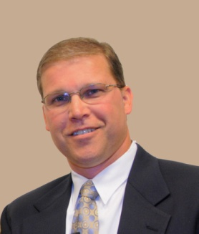**Russ Campbell, PT,** is an award-winning therapist and received his degree from Northwestern University in 1989. Over his 27 years of clinical practice he has provided care in acute care hospitals, inpatient rehab units, skilled nursing facilities, outpatient clinics and home health arenas. Russ specializes in using modalities in conjunction with a holistic approach to foster faster outcomes to maximize the quality of life of the elderly patient. He has provided over 500 continuing education trainings to physical, occupational and speech therapists across the country.

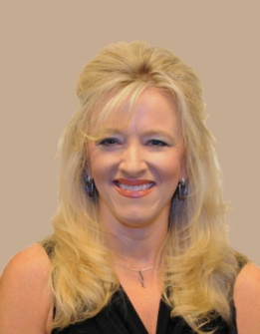**Ronda Polansky, MS, CCC-SLP,** is an ASHA-certified Speech Language Pathologist and owner of DiagnosTEX, a mobile Modified Barium Swallow Study company in Dallas/Fort Worth, Texas. She has more than 20 years of experience specializing in dysphagia and has performed over 15,000 Modified Barium Swallow Studies (MBSS). Ronda has led CE courses and has published materials on dysphagia. She received her Masters degree in Communication Science Disorders/Speech Pathology from Texas Woman’s University in 1992.

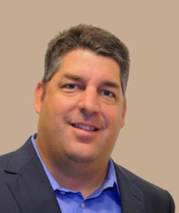**Rick McAdoo, MS, CCC-SLP,** received a Bachelors of Science in Speech-Language Pathology from Texas Christian University in 1989 and received his Masters of Science in Speech-Language Pathology from Texas Christian University in 1990. He has worked primarily with the adult neurogenic population with specialized emphasis in dysphagia. Over the past 15 years his focus has included a research component and was the first to show laryngeal elevation using transcutaneous electrical stimulation on both a computerized laryngeal analyzer and under video fluoroscopy.

Course instructors may vary based on the number of attendees.

**Disclosure Statements:**

Russ Campbell, PT, Disclosures: Financial: Russ has intellectual property rights, holds a patent on Ampcare ESP Technology and receives compensation for its sale. He is employed by and has ownership interests in Ampcare, LLC, and receives a salary. Nonfinancial: He has no relevant nonfinancial relationships to disclose.

Rick McAdoo, MS, CCC-SLP, Disclosures: Financial: Rick has intellectual property rights, holds a patent on Ampcare ESP Technology and receives compensation for its sale. He is employed by and has ownership interests in Ampcare, LLC, and receives a salary. Nonfinancial: He has no relevant nonfinancial relationships to disclose.

Ronda Polansky, MS, CCC-SLP, Disclosures: Financial: Ronda has intellectual property rights, holds a patent on the Ampcare ESP Technology and receives compensation for its sale. She has ownership interests in Ampcare, LLC. Nonfinancial: She has no relevant nonfinancial relationships to disclose.



**Location Information**

**DoubleTree by Hilton Hotel Sheffield Park**

Chesterfield Road South

Sheffield, S8 8BW

United Kingdom

TEL: 0114 2829988

Overnight accommodation and parking are the responsibility of the participant. Book a room by 4thSeptember and use code “**GNHSA**” to receive a discounted rate for your overnight stay on Sunday 2nd October. Prices with discount code: £70.00 B&B Single Occupancy, £80.00 B&B Double Occupancy.

**Payment Information (fees due by 30 September 2016)**

**Trust**

**Name & Department to Whom the Invoice Should be Sent**

**Trust Address**

** In the event you wish to self-fund, please contact Irene for alternative payment methods;  
Contact number for enquiries: 0114 2712676.

**Amount to be invoiced:\***

**Course Training Only £150 🞎\***

**Course & ESP Kit £774 🞎\***

**Course & 10 Packages of E-Series Electrodes £225 🞎\***

* Place a tick in the appropriate box. Please see below for an explanation of the various fees.

* Course & ESP Kit includes discounted course fee of £125 and ESP Kit for £649 plus VAT.  
  ESP Kit contains: Ampcare ES NMES Unit, Carrying Case, User’s Manual, 2 Lead Wires, 2 AA Batteries,  
  10 packages of E-Series Electrodes, and Posture Device.
* Course & 10 Packages of E-Series Electrodes, option offered if a Trust is sending multiple registrants and purchasing at least one ESP Kit, includes discounts: course fee of £125 and Electrodes for £100 plus VAT.

Cancellation: Paid registrations are non-refundable unless Ampcare cancels the seminar. A full refund will be given if Ampcare cancels the seminar for any reason.

Special Needs: Indicate any special assistance required when you register (e.g. dietary, physical disability, etc.).

**Registrant Information**

**First Name Last Name**

**Credentials to be Placed on Certificate**

**Email**

**Telephone Dietary Needs**

**Registration for 3 October 2016**

**Deciphering Dysphagia with Ampcare’s ESP™**

To register, please email this completed form to:

Irene Wilson, Course Administrator Sheffield Teaching Hospitals NHS FT

[irene.wilson@sth.nhs.uk](mailto:irene.wilson@sth.nhs.uk)